Alcohol: Global Statistics

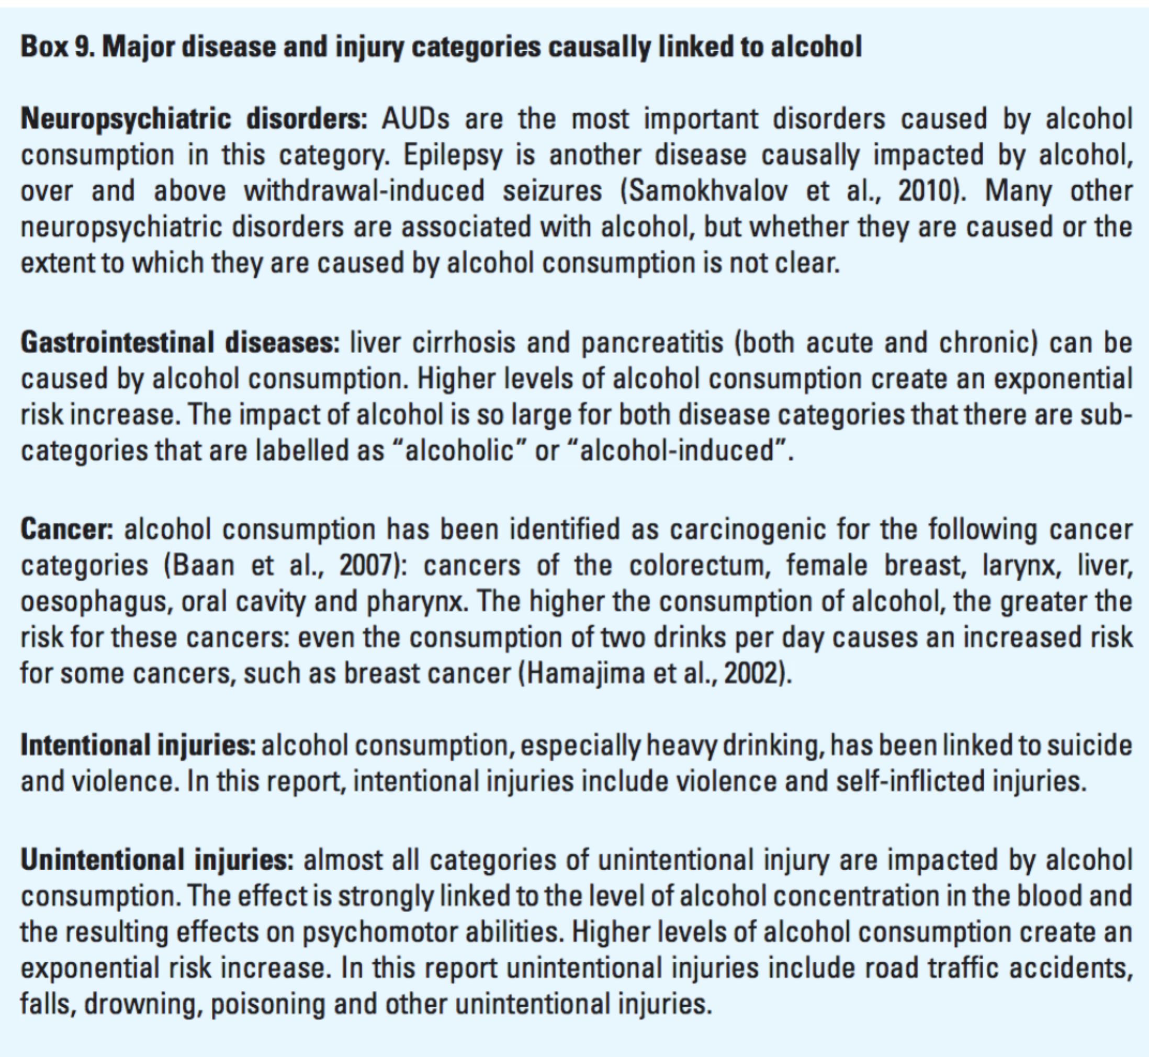
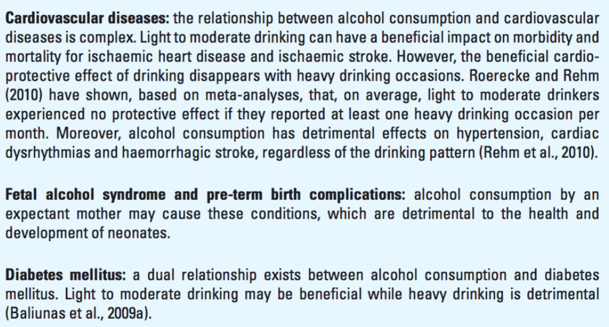

“In addition to the disease and injury categories listed in Box 9, new evidence points to a causal link between alcohol and infectious diseases. Namely, alcohol consumption weakens the immune system, thus enabling infections by pathogens, which cause pneumonia and tuberculosis. This effect is markedly more pronounced with heavy drinking and there may be a threshold effect (Lönnroth et al., 2008). A strong association exists between alcohol consumption and HIV infection and sexually transmitted diseases (Baliunas et al., 2009b). It may be that a common third cause, such as having particular personality traits, impacts on both alcohol consumption and risky sexual behaviour leading to infectious diseases (Shuper et al., 2010). However, there is a clear causal effect of alcohol consumption on HIV/AIDS patients’ adherence to antiretroviral treatment (Hendershot et al., 2009).

Alcohol-attributable deaths are defined as the number of deaths attributable to alcohol consumption. They assume a counterfactual scenario of no alcohol consumption. Thus, alcohol-attributable deaths are those deaths that would not have happened without the presence of alcohol.”
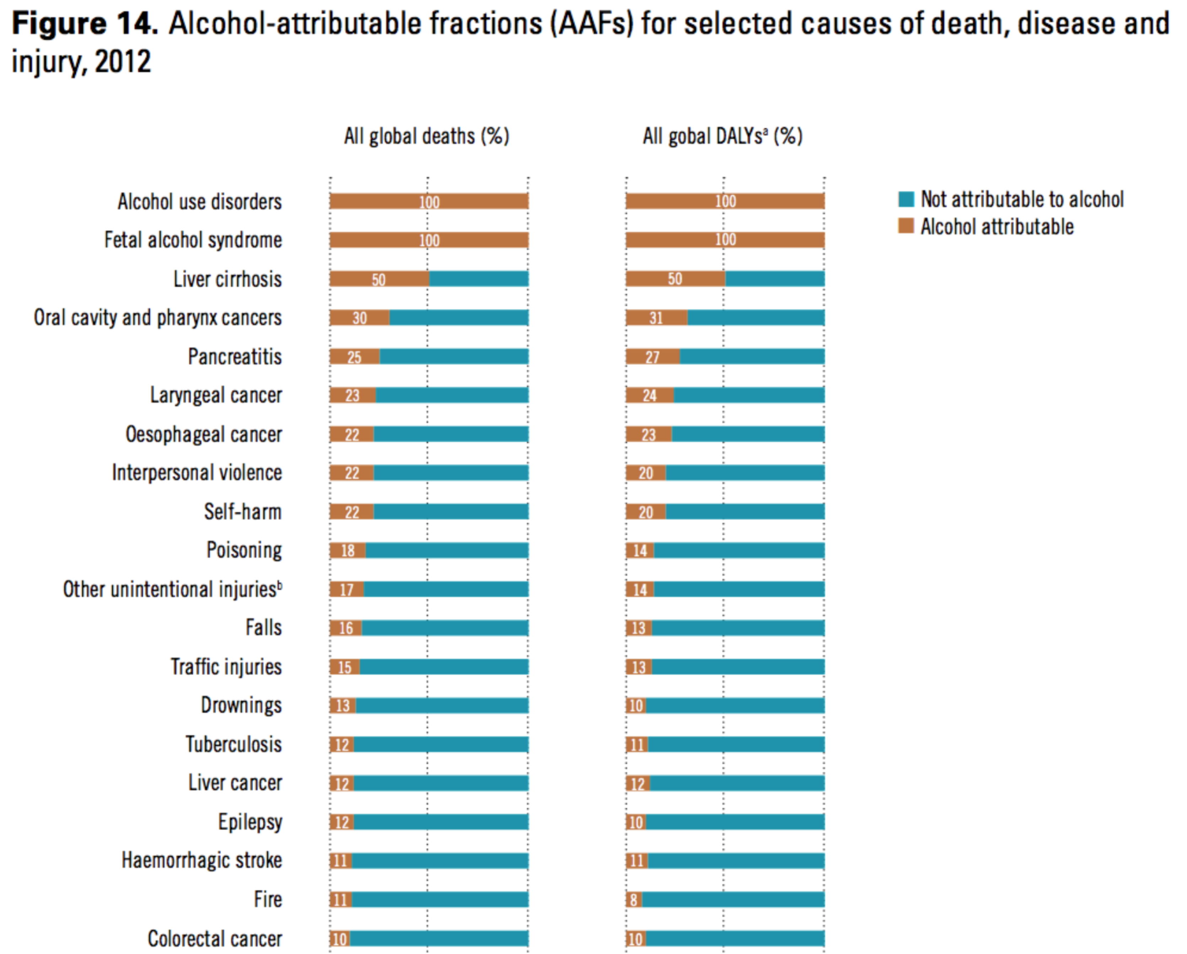
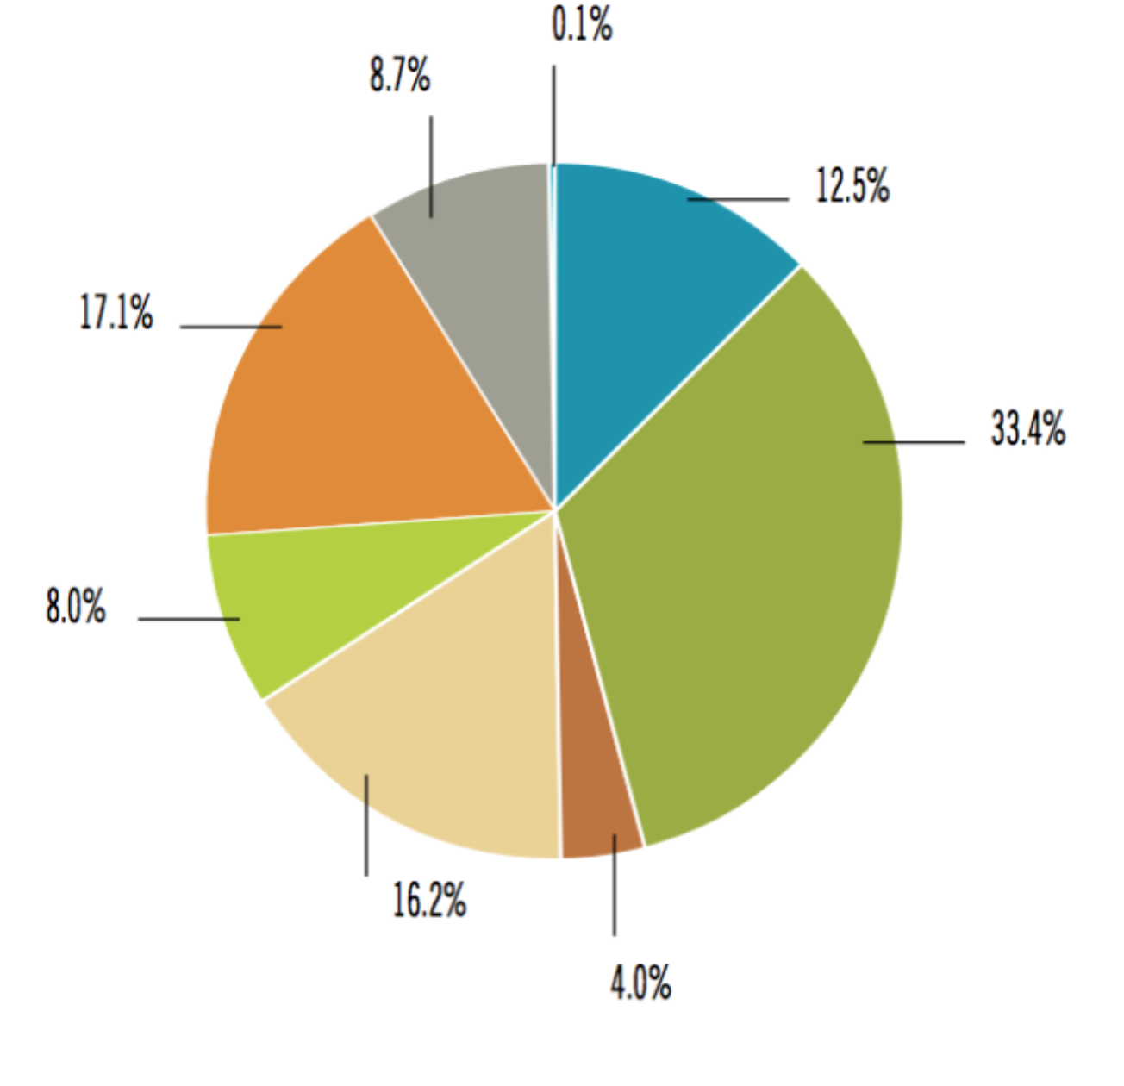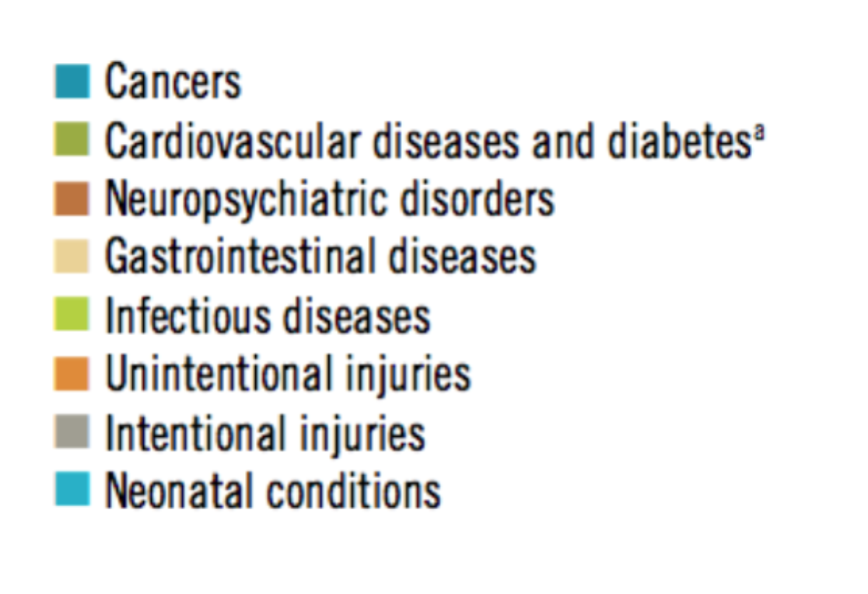
Most of the deaths caused by alcohol were in the categories of injury, cancer, cardiovascular disease and liver cirrhosis. Intentional and unintentional injuries account for 42% of all alcohol-attributable deaths (Table 8), which underlines the importance of addressing the intoxication propensities of alcohol. Alcohol-attributable deaths from neuropsychiatric disorders consist of 65% deaths due to alcohol use disorders and 35% deaths due to epilepsy and unipolar depressive disorder.
Sources: REPORTS :
http://www.who.int/substance_abuse/publications/global_alcohol_report/msbgsruprofiles.pdf
http://apps.who.int/iris/bitstream/10665/112736/1/9789240692763_eng.pdf

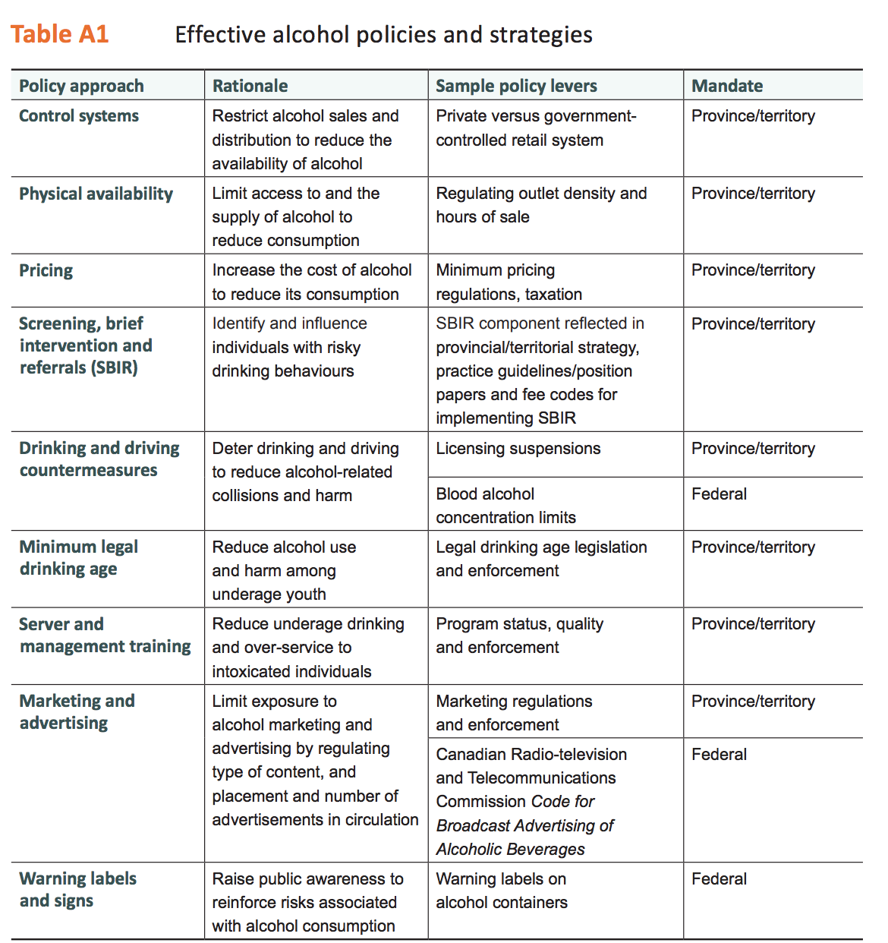

Source: https://www.cihi.ca/sites/default/files/document/report-alcohol-hospitalizations-en-web.pdf

