Alcohol - Statistics and Policies for Canada

Content is taken from online report and supplemented with abstracts from referenced articles.
https://www.cihi.ca/sites/default/files/document/report-alcohol-hospitalizations-en-web.pdf

Pricing Policy
Pricing policies aim to make alcohol less affordable. There are a number of pricing policy options available, such as minimum pricing, pricing on alcohol content, restricting discounts and taxation. Minimum prices are the lowest price at which alcohol can be sold. Adjusting the cost of alcohol to inflation ensures that alcohol does not become cheaper than other goods over time. Adjusting the cost of alcohol based on alcohol content promotes the consumption of lower-strength products because these products are the most affordable.

Evidence: Increasing the price of alcohol

Alcohol pricing policies are the most effective and cost-effective method of reducing alcohol consumption and alcohol harm. Pricing policies that reduce the affordability of inexpensive alcohol have been found to be more effective at decreasing consumption among heavy or harmful drinkers than among those who are light to moderate drinkers.

In Canada, 2 studies found that a 10% increase in minimum alcohol price led to a 3% and 8% reduction in alcohol consumption in British Columbia and Saskatchewan, respectively.

Results from the Saskatchewan study
Impacts on alcohol consumption following new and increased minimum alcohol prices in Saskatchewan, Canada
Results: A 10% increase in minimum prices significantly reduced consumption of beer by 10.06%, spirits by 5.87%, wine by 4.58%, and all beverages combined by 8.43%. Consumption of coolers decreased significantly by 13.2%, cocktails by 21.3%, and liqueurs by 5.3%. There were larger effects for purely off-premise sales (e.g., liquor stores) than for primarily on-premise sales (e.g., bars, restaurants). Consumption of higher strength beer and wine declined the most. A 10% increase in minimum price was associated with a 22.0% decrease in consumption of higher strength beer (> 6.5% alcohol/volume) versus 8.17% for lower strength beers. The neighboring province of Alberta showed no change in per capita alcohol consumption before and after the intervention.

Results from the BC study

Minimum alcohol prices in British Columbia have been adjusted intermittently over the past 20 years. The present study estimates impacts of these adjustments on alcohol consumption
Participants The population of British Columbia, Canada, aged 15 years and over.
Measurements Data on alcohol prices and sales for different beverages were provided by the BC Liquor Distribution Branch for 1989–2010. Data on household income were sourced from Statistics Canada.
Findings: Longitudinal estimates suggest that a 10% increase in the minimum price of an alcoholic beverage reduced its consumption relative to other beverages by 16.1% (P < 0.001). Time–series estimates indicate that a 10% increase in minimum prices reduced consumption of spirits and liqueurs by 6.8% (P = 0.004), wine by 8.9% (P = 0.033), alcoholic sodas and ciders by 13.9% (P = 0.067), beer by 1.5% (P = 0.043) and all alcoholic drinks by 3.4% (P = 0.007).

Canada-wide results: Alcohol pricing policies vary
Most jurisdictions legislate minimum alcohol prices (see Table 2). However, most provinces do not index the minimum prices of all alcoholic beverage types to inflation, and even fewer provinces adjust their minimum prices for alcohol content. 4 provinces — Nova Scotia, New Brunswick, Ontario and Manitoba — index minimum prices for all types of alcohol to inflation and have lower levels of alcohol consumption

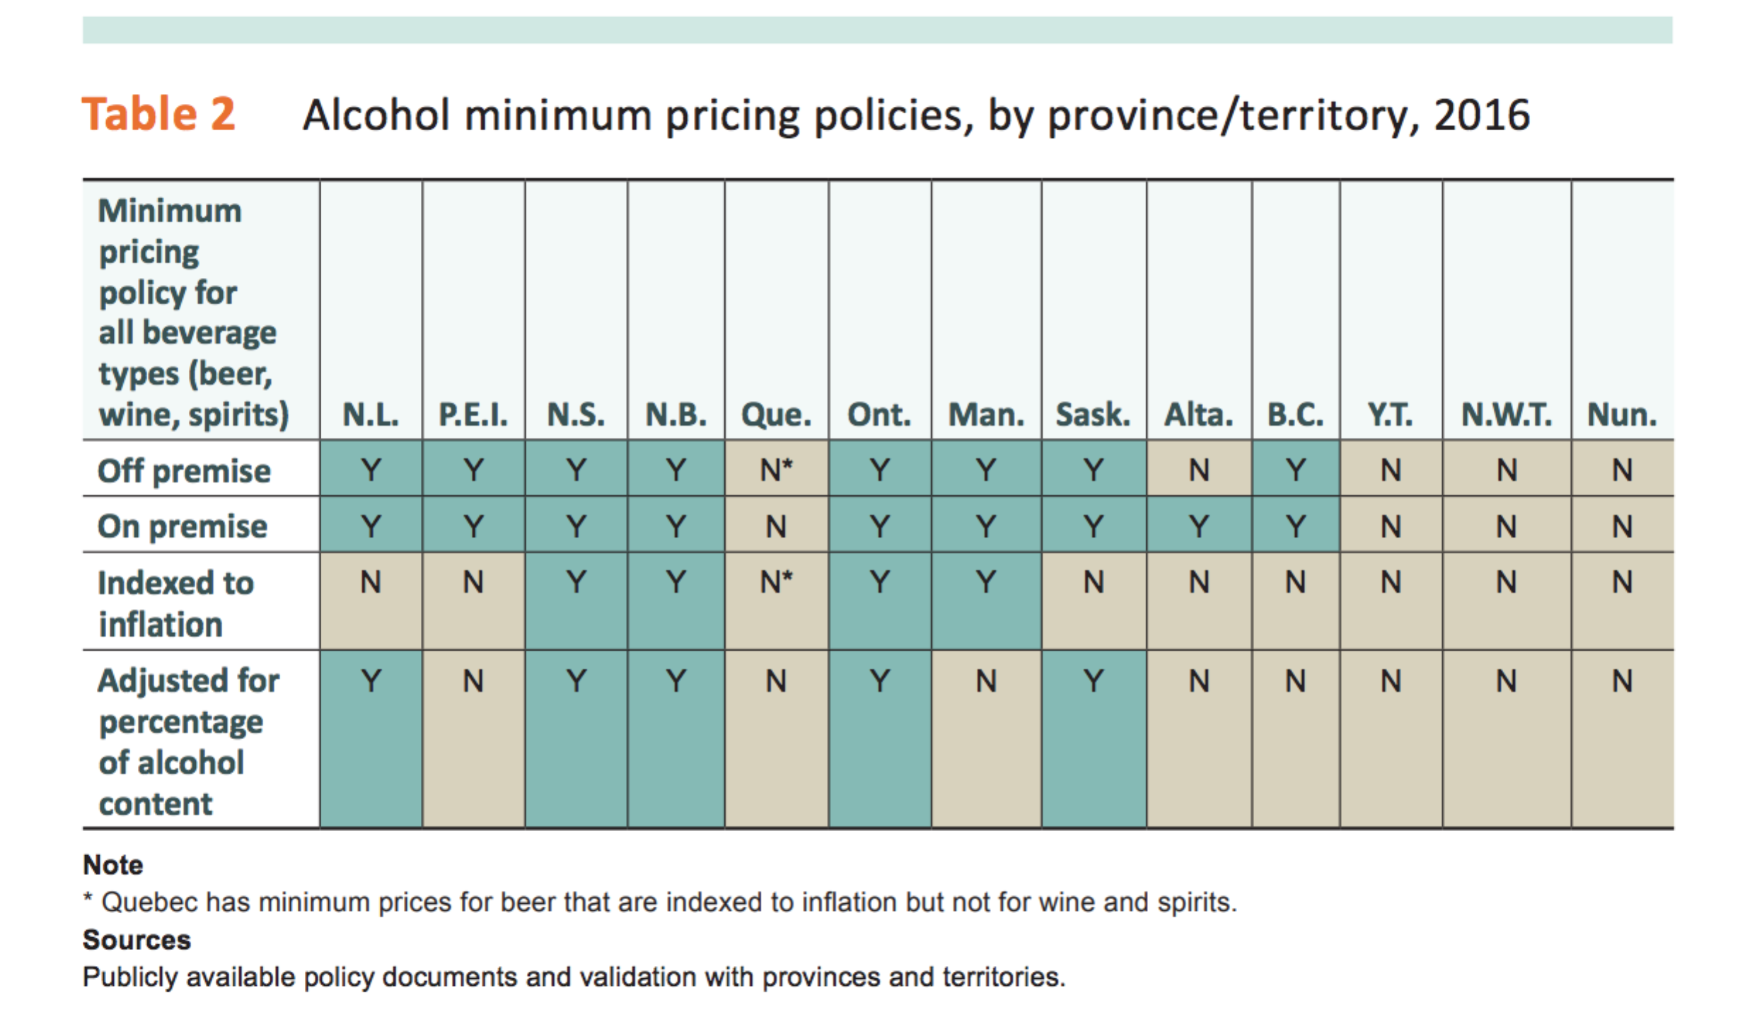

Minimum legal Drinking Age

Canadian Drinking-Age Laws Have Significant Effect on Deaths Among Young Males

Currently, the minimum legal drinking age is 18 years of age in Alberta, Manitoba, and Québec, and 19 years in the rest of the country. Using national Canadian death data from 1980 to 2009, researchers examined the causes of deaths of individuals who died between 16 and 22 years of age. They found that immediately following the minimum legal drinking age, male deaths due to injuries rose sharply by 10 to 16 per cent, and male deaths due to motor vehicle accidents increased suddenly by 13 to 15 per cent.

Source: https://www.cihi.ca/sites/default/files/document/report-alcohol-hospitalizations-en-web.pdf

Tim Stockwell, Jinhui Zhao, Norman Giesbrecht, Scott Macdonald, Gerald Thomas, Ashley Wettlaufer. (2012), “The Raising of Minimum Alcohol Prices in Saskatchewan, Canada: Impacts on Consumption and Implications for Public Health”, American Journal of Public Health, 102: e103-e110.
Stockwell, T., Auld, M. C., Zhao, J. and Martin, G. (2012), Does minimum pricing reduce alcohol consumption? The experience of a Canadian province. Addiction, 107: 912–920.
https://www.unbc.ca/releases/11685/canadian-drinking-age-laws-have-significant-effect-on-deaths-among-young-males

